Chapter 14, Problem 103.

The RC circuit in Fig. 14.111 is used for a lead compensator in a system design. Obtain the transfer function of the circuit.

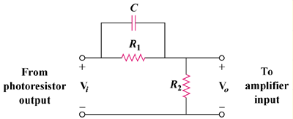

Figure 14.111
For Prob. 14.103.

